
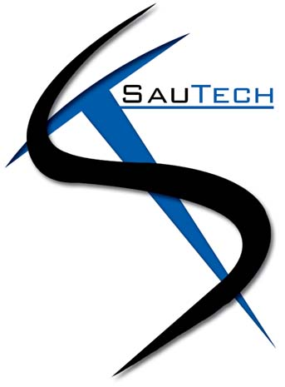

BUSINESS PLAN

SAU TECHNOLOGY HOSTING and
DISASTER RECOVERY (Pty) Ltd

CONTENTS
1 BUSINESS DISCRIPTION 3
1.1 Why Namibia 3
1.2 Government 3
1.3 Staff Enablement 4
2 COMPETITION 4
3 MARKETING 4
4 PEOPLE 5
5 BUDGETING AND FORECASTING 5

BUSINESS DISCRIPTION

SAU TECHONOLOGY HOSTING AND DISASTER RECOVERY (Pty) Ltd (hereinafter referred to as “Sautech Namibia”) is a niche hosting and cyber security company. Our roots come from South-Africa where we have been successfully managing and supporting the industry for the past 20 (twenty) years.

Our key focus is driving the reseller model within the already established IT industry. We have partnered with key suppliers within the Namibian and South-African industry to be able to deliver our services.

Cyber security as well as clients whom have taken out cyber insurance in the Namibian market, is less than 5% (five percent). Sautech Namibia’s goal, is to drive this market to reach 20% (twenty percent) within a 5 (five) year period.

SAUTECH NAMIBIAN PARTNERS: | SAUTECH SOUTH-AFRICAN PARTNERS
Paratus Hosting | Afrihost
Salt | Microsoft
ITOO (Hollard Insurance) | Reportstar
Microsoft | Xneelo
Veeam | Rectron
Synology | Tarsus Technologies
SpamTitan | ITOO (Hollard Insurance)
Multiple Resellers | Multiple Resellers

With our supplier either overlapping and/or being unique, the calibration between the two entities, brands our solution offering much more appealing across the board.

Why Namibia

Namibia has always been a beautiful, culturally country, similar than South-Africa. The Rand and Namibian Dollar is 1-1 (one to one), which simplifies costing.

As Namibia has been seen as an extremely well positioned growing economy (with the new Google internet cables landing in Walvis Bay), Sautech RSA has thought it prudent to assist and offer technology related services to the Namibian Market.

Namibia, having a host of sister South-African businesses (already established), and with Sautech RSA managing and supporting numerous holding companies in South-Africa, it has made it a logical step to support and manage the sister companies in Namibia as well.

Sautech RSA already supports companies in multiple African counties and as such, we would like to stay in Africa, later expanding into Angola.
Namibia, being close to Angola, makes it a strategic location to start the expansion into the rest of West-Africa, which is convenient and a mutual beneficial for the Namibian Entity of Sautech.

Government

The Government in Namibia is stable and democratically elected, and this being a key requirement for Sautech to establish a business in a neighbouring country.

Staff Enablement

Sautech Namibia’s drive, is to enable and teach the Namibian residents and companies our intellectual property obtained in RSA in order to enhance skills, talent and cost savings.
Our focus thus, is to partner with locally owned and established IT consulting companies, and provide services and products to offer to their clients.
By reducing the cost in the market and expanding product base, the locally owned companies can thus recruit and create employment for Namibians.
Sautech Namibia will focus on achieving this drive realistically and within a 5 (five) year time frame.

COMPETITION

Sautech Namibia does have competition in some of our reseller pricing and services models, however, our reseller model and business network give us the edge namely the following:

- Pricing: we are as a minimum, 40% (forty percent) more affordable than our nearest competitor.
- Uniqueness: ITOO Cyber Insurance will only cover our niche product once the disaster recovery, backups and cyber security software is either with Sautech Namibia, or with one of our approved partners, as per our agreement with them.
- Diversification: we provide multiple solutions and scenarios to hosting (and not just white labelled products).
- Expert knowledge and backup from our Southern-African operation, the backup support structure is vast.
- Multiple hosting locations: we can offer cross country replication to any of our multiple datacentres.
- Experience in hosting and cyber security: as we have gone through multiple ransomware attacks, our experience gives us the edge to prevent, maintain and manage cyber incidents.
- Hosting centres: although Namibia has limited bandwidth and hosting centres, we can offer cross continent hosting at reduced rates but, with a physical presence in Namibia.
- Establish products, services and software that we replicate to Namibia: we do not have to create and build everything from the ground up, as the shareholders are basically the same in both countries and the intellectual property is easily transferable.

In closing, it is beneficial for our competitors to work with us. Our unique model caters to work together, rather than against each other.

MARKETING

Marketing has always been the “make or break” of any business. Sautech Namibia has thought this through thoroughly, and as such, the following will be implemented:

- We do not focus on end users, therefor, marketing on social media will occur.
- We market and focus on our competitors, as such, face to face meetings with the selected top 50 (fifty)
IT businesses in Namibia, is vital.
- Each reseller has an “already established” client base with end users, which we will tap into in order to deliver our products, hence, simplifying the sale and convincing strategies.
- As we have our own product with Hollard ITOO, we already have a cost-effective unique product offering in the market.
- With our immense experience in technologies, our sales force will be the product, and not the marketing aspect. We will continually drive our resellers and manage those relationships.
- Together with our partners, we will drive roadshows on our cyber insurance products. Our resellers already have a massive support network to tap into and as such, the client reach is bigger from the word go.
- Marketing to an established South-African client to have similar, replicated services hosted in Namibia, is ongoing. (Numerous of our clients have clients as well as sister businesses in Namibia, for introductions).
- We can tap into “already established” relationships and networks.

PEOPLE

Sautech RSA have a reseller model, “our clients are our people”. As our solutions (developed in South-Africa) are delivered and marketed to our resellers, the resellers staff base will continue to grow.

Key individuals to deliver these services are:

Riaan van Jaarsveld
Managing Director - Sautech Group

and

Lukas Janse van Rensburg
IT Director - Sautech Namibia

The above two key individuals will be supported by the South-African staff compliments. Our established network of partners and suppliers, and together with our “on the ground resellers and support staff”, we are able to effectively deliver our solutions.

We are about cost saving, enhanced technology and solutions. With us delivering the correct pricing model and products, we will empower our resellers to grow the staff base with local Namibian talent.

Sautech Namibia plan to operate with maximum 5 (five) employed staff within the first 2 (two) years of operation. We are planning to utilize local outsourced talent for the performing of:
administration functions, accounting, compliance and support.
Our model is a reseller model, thus, when we deliver, our reseller delivers, thus, creating more job opportunities for local Namibian residents.

BUDGETING AND FORECASTING

Sautech RSA has decided to invest 2,5 Million ZAR into the Namibian operation from a cash perspective. Together with this, the time and services from Sautech RSA representatives will also add to the total injection, as these services will be invoiced from a loan account perspective.

Our objective, to be profitable within the first 12 (twelve) months.
Our key driver, to achieve this realistically and so optimistically, Managing Director, Riaan van Jaarsveld, has setup multiple successful business in the past.
Our staff compliment in RSA is trained, professional, and the support structure from our suppliers and partners, will make our end goal achievable.

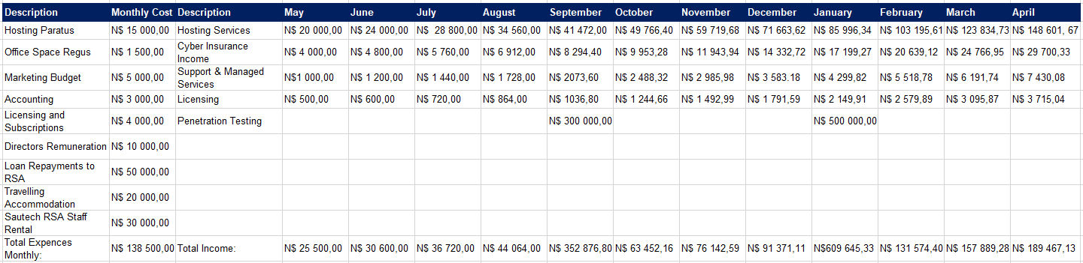

In the above analysis, we anticipate the “break-even” to be found February 2024, including 2 (two) lumpsum injections in September 2023 and January 2023 (when conducting cyber security penetration testing).
Depreciation costs have not been factored in, as the hardware will be supplied by Sautech RSA and will form part of the loan agreements. We have also not factored in the 29% (twenty nine percent) corporate tax within the first year of “break-even”, as our financial year end will be 28th February, and any surplus funds will be used to pay off Sautech RSA’s loans first.

